An Improved INS/VNS Integrated Navigation Measurement Model for Lunar Rover

Yongzhi Xu
School of Instrument Science & Opto-electronics engineering, Beihang University
Beijing, China
e-mail: buaaxyz@yeah.net
Xiaolin Ning
School of Instrument Science & Opto-electronics engineering, Beihang University
Beijing, China
e-mail: ningxiaolin@buaa.edu.cn

Abstract—The INS/VNS integrated navigation is an important autonomous navigation method for lunar rovers. The INS/VNS models usually utilize the relative motion differences between the inertial and the vision as measurements. Traditional INS/VNS models make an approximation between definitions of the inertial measured attitude error and the misalignment angle to simplify the measurement model of relative rotation difference. This paper finds that the norm of the approximation error can exceed the norm of misalignment angle when the yaw is large, which cannot be ignored. Furthermore, an improved measurement model without that approximation is presented, in which the definition of inertial measured attitude error and the misalignment angle is accurately matched. Lunar based simulation and earth based experiment both demonstrate that the presented model is effective and can achieve higher accuracy of positions and attitudes than traditional models.
Keywords-Inertial navigation； Vision navigation；Integrated navigation； Measurement model； Lunar rover

Introduction
High-accuracy autonomous navigation is one of the key technologies for planetary rover. Inertial and vision integrated navigation (INS/VNS) methods are usually used for planetary rovers, such as in China’s first lunar rover, Yutu [1], and NASA’s Curiosity [2]. INS/VNS methods usually utilizes the inertial error model to build the state model, and the vision information to build the measurement model [3,4]. The INS/VNS models which utilizes the relative motion difference between inertial and vision as measurement [5,6], are effective and analyzed in this paper.
Traditional INS/VNS models make an approximation between the definition of inertial measured attitude error and misalignment angle to simplify the measurement model.

Reference Frames
The reference coordinate frames are all defined as right hand frames, including the inertial frame(i,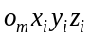), the moon fixed frame(m,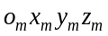), the geographic frame(t,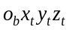), the world frame(w,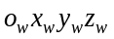), the body frame(b,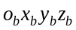) and the camera frame(c,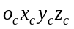), some of which are show in Fig 1. In t-frame, the x-axis points to the east and the y-axis points to the north. The w-frame is defined as the first instant t-frame. In b-frame, the x-axis points to the right of the rover and the y-axis points to the front of the rover. The origin of c-frame is at the left camera, its x-axis points to the right of the camera and its y-axis points downward.
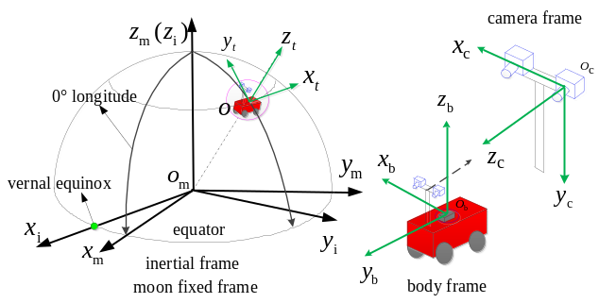Figure 1 Coordinate frames

State Model
The state model which utilizes the motion errors and the IMU drift as states can be written as:
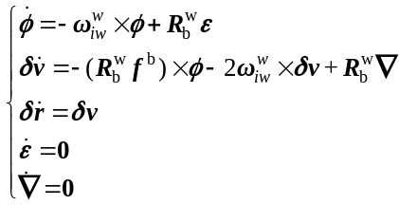
where is the attitude error angle, 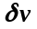 is the velocity error, 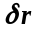is the position error, is the gyroscopes drift, and is the accelerometers bias. 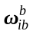 and 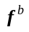 are the data of gyroscopes and accelerometers respectively. 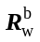 is the attitude matrix, 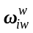is the angular velocity of the w-frame relative to the i-frame expressed in the w-frame.

Measurement Model Based on Relative Motion Difference

Measurement of The Relative Motion Difference
The frequency of the vision data is commonly lower than the inertial data, so the data fusion frequency is the same as the vision frequency. All the in this paper denotes the k instant of data fusion.
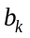 is the b-frame at . 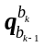 and 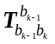 are the relative rotation quaternion and translation vector from to 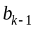, which are usually called as relative motion. The difference of the inertial and the vision relative motion is used as the measurement.

Inertial relative motion: 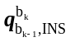 and 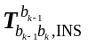 are the inertial relative motions, which can be computed as:
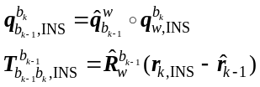
where 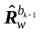and 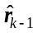 are INS/VNS estimated attitude matrix and position vector at 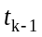 respectively. 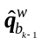 is the quaternion of . 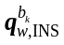 and 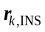 are inertial calculated attitude quaternion and position at respectively.

Vision relative motion: The procedure of vision navigation system mainly includes feature extraction, feature tracking, stereo matching, 3D reconstruction and motion estimation. By 3D reconstruction, the coordinates of feature points in c-frame are 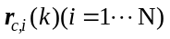, where 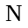 is the number of feature points. 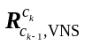 and 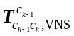 are the vision relative motion parameters in c-frame, which can be calculated as follows:
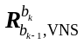 and 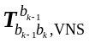 are the corresponding vision relative motion parameters in b-frame, which can be calculated as follows:
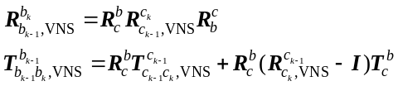
where 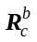 and 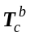 are the rotation matrix and translation vector from c-frame to b-frame.
The measurement can be computed as:
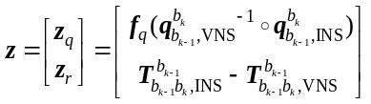
where 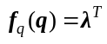 when 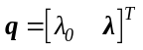.

Traditional Measurement model
To simplify the measurement model, the traditional methods analyze the error of the relative motion as follows.

Traditional measurement model of 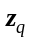: The error of 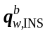 is defined as:
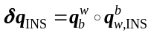
where 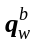 is the real attitude quaternion.
As the definition of is:
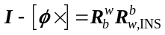
the relationship of 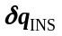 and is:
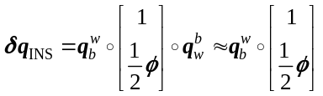
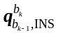 can be expressed as:
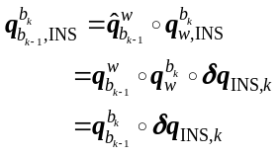
The error of 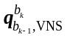 is defined as:
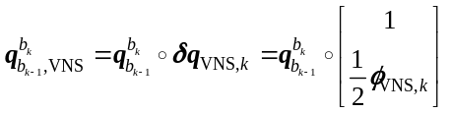
The measurement model of can be expressed as:
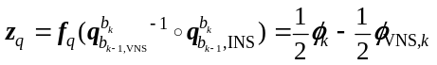

Traditional measurement model of : As 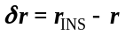, can be written as:
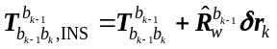
can be written as:
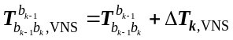
The measurement model of can be expressed as:
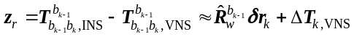

Traditional measurement model: In summary, the traditional measurement model can be expressed as:
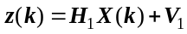
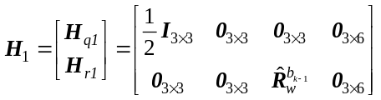
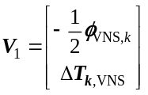

Error Analysis of Traditional Measurement model
The traditional measurement model makes an approximation between the definition of and to simplify the measurement model of in . The error caused by the approximation can be written as 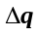:
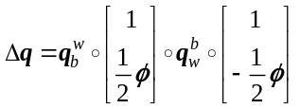
The angle of is 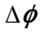. Define to describe the relative error of :
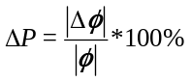
Fig 2 shows analysis when the yaw is from 0° to 360°, the pitch and roll is 3°, and is 0.02°. It can be seen from Fig 2, changes from 0 to 160%, and can exceed 100% when the yaw is large. Meanwhile, the change of the pitch and roll from -5° to 5°, and the norm of do not affect . In summary, the norm of can exceed when the yaw is large, which cannot be ignored.
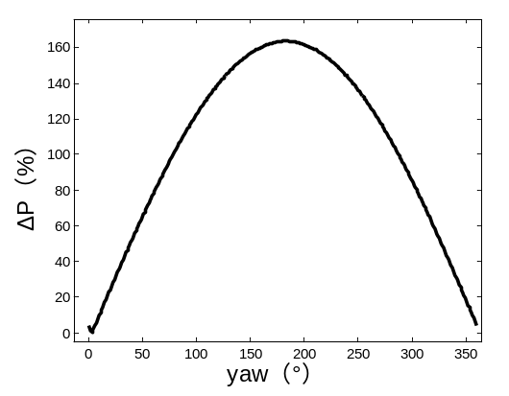
Figure 2 analysis

New Measurement Model of The Relative Rotation Difference
To avoid the approximation between the definition of and in the traditional method, an improved relative rotation difference measurement model is presented. The new error definition of is:
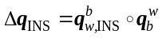
According to the definition of in the state model , there is an accurate relationship as follows:
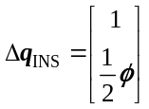
Then can be expressed:
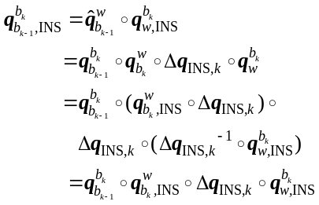
The corresponding measurement model of is:
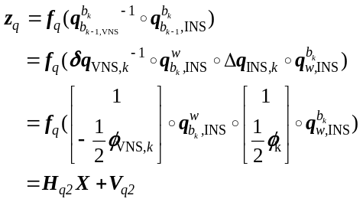
where 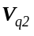 is the corresponding measurement noise as follows:
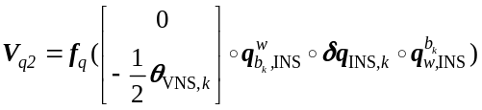
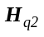 is the corresponding improved measurement matrix:
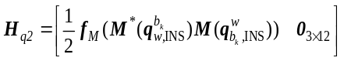
The function 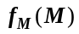 is defined as:
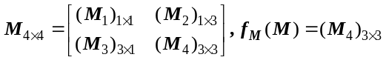

Simulation and Experiment

Simulation
Due to limitations in experimental conditions and cost, real experiments on the Moon cannot be achieved. The simulated IMU data and images on the Moon conditions are produced by a simulation system. The IMU data is produced by an inertial path generator and the images are produced by a 3DS MAX scene. The 3DS MAX scene is built based on images of the lunar surface from NASA, a typical of which is shown in Fig 3.
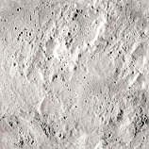
Figure 3 A typical lunar surface image

Simulation conditions: The constant bias and random drift of gyroscopes are 1 °/h and 0.5 °/h, respectively. The constant bias and random drift of the accelerometers are 100 µg and 50 µg, respectively. The simulated binocular visual system is a pair of parallel installed cameras, with the baseline of 20cm and the height of 1.7m from the surface. The image resolution is 1392×1040 pixels, and the view field is 45.76°×35.00°. The frequencies of INS and VNS are 100 HZ and 0.2 HZ respectively.

The simulation results: The simulation trajectories of INS, VNS, traditional INS/VNS(INT1) and improved INS/VNS(INT2) navigation methods are shown in Fig 4. As the INS position errors are too large, its trajectory is not compared in Fig4.As can be seen in Fig4, the position errors of INT1 and INT2 are quite smaller than VNS, which demonstrate that the two integrated navigation methods are effective. Furthermore, the INT2 trajectory is closer to the ideal trajectory than INT1 in the whole trace, which indicates the position accuracy improvement of INT2 compared with INT1 .
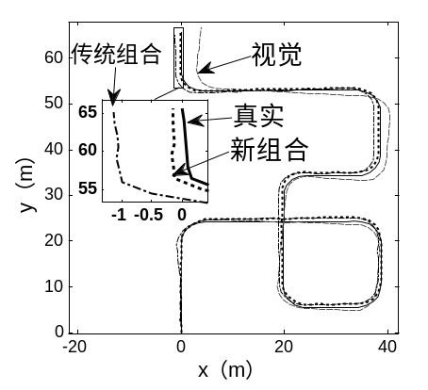
Figure 4 Simulation trajectories
Table 1 compares the final position and attitude errors of the four navigation methods in the simulation. It can be seen from table 1, VNS achieves higher position accuracy than INS, and INS achieves higher attitude accuracy than VNS. The position and attitude accuracies of both INT1 and INT2 are higher than INS and VNS, which demonstrates that the two integrated INS/VNS navigation methods are effective. The position errors of INT1 is 1.238m, which is 0.611% of the trace length204.24m. The position errors of INT2 is 0.079%, which has improved 87.07% compared with INT1. INT2 achieves higher attitude accuracies than INT1, especially in the yaw direction. The yaw errors of INT2 is -0.221°, which has improved 58.46% of INT2’s 0.532°. As the position accuracy of vision system is sensitive to the yaw accuracy , the increase of yaw accuracy in INT1 is extremely beneficial. Summary, their is a significant improvement in both position and attitude performance of INT1 compared with INS, VNS and INT2.
Table 1. Simulation final position and attitude errors
methods | final position errors |  |  | final attitude errors(°)
methods | absolute  value(m) | percentage  (%) | pitch |  | roll | yaw
INS | 21386 | 10475 | 0.609 |  | 0.596 | 1.876
VNS | 4.086 | 2.001 | 1.050 |  | -0.098 | -6.262
INT1 | 1.238 | 0.611 | -0.008 |  | 0.000 | 0.532
INT2 | 0.159 | 0.079 | 0.008 |  | 0.007 | -0.221

Experiment

Experiment conditions: Though the gravity, rotational speed and surface images on Earth are different from on the Moon, the earth based experiment is feasible and beneficial to verify the navigation methods. The dataset 2011_09_30_drive_0028 of KITTI Vision is used in the experiment, in which the car drives 8.38 minutes and 4128.86m.
The constant bias of the gyroscopes is 0.01°/s, the constant bias of accelerometers is 1020.4μg. The frequency of IMU data is 100HZ. The baseline of the binocular cameras is 54cm and the height from the ground surface is 1.65 m. The image resolution is 1226×370, and the image frequency is 10HZ. A typical image taken in the experiment is shown in Fig 3.
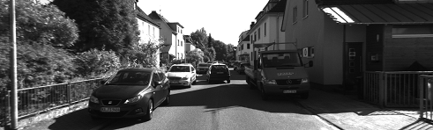
Figure 5 A typical experiment image

Experiment results: Fig 6 compares the position trajectories, which clearly shows the position accuracy improvement of INT2 compared with INT1 and VNS. The INT2 trajectory is much closer to the ideal trajectory than INT1 and VNS in the whole trace. Table 2 compares the final position and attitude errors of the four navigation methods. It can be seen from table 2, The position accuracy of INT2 is 0.143%, which has improved 68.64% compared with INT1’s 0.456%. The attitude accuracies of INT2 are all higher than INT1. Especially, the yaw accuracy of INT2 is -0.105°, which has improved 87.04% compared with INT1’s 0.810°.
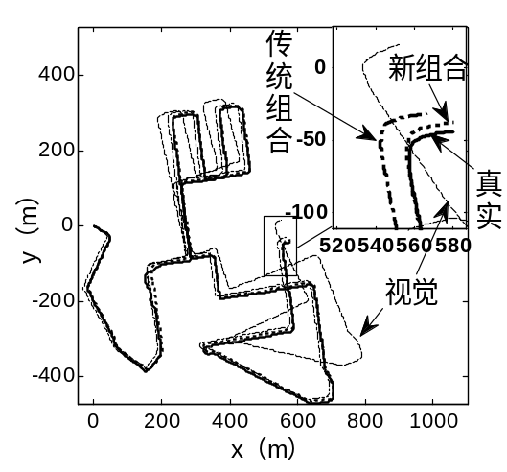
Figure 6 Experiment trajectories
Table 2. Experiment final position and attitude errors
methods | final position errors |  | final attitude errors(°)
methods | absolute value(m) | percentage  (%) | pitch | roll | yaw
INS | 59906 | 1450.9 | 1.935 | -0.946 | 0.181
VNS | 66.706 | 1.615 | 6.075 | 12.176 | 17.681
INT1 | 18.845 | 0.456 | 1.649 | -1.464 | 0.810
INT2 | 5.908 | 0.143 | -1.381 | 0.648 | -0.105

Conclusion
The traditional INS/VNS models which utilizes the relative motion difference between the inertial and the vision, make an approximation between definitions of the inertial measured attitude error and the misalignment angle. By analysis under typical conditions, the norm of approximation error is found can exceed the norm of misalignment angle, which cannot be ignored. An improved measurement model is presented, which defines the inertial measured attitude error same as the misalignment angle to avoid the approximation. In the lunar based simulation, the position accuracy is improved 87.07%. In the earth based experiment, the position accuracy is improved68.64%. In summary, the simulation and experiment both demonstrate the presented INS/VNS model is efficient and can achieve higher position and attitude accuracies than traditional models.

- Liu Chuankai, Wang Baofeng, Wang Jia，et al．Integrated INSand vision based orientation determination and positioning of CE 3 lunar rover[J]．Journal of Spacecraft TT&C Technology，2014，33(3)：250-257.
- Maimone M, Cheng Y, Matthies L. Two years of visual odometry on the mars exploration rovers [J]. Journal of Field Robotics, 2007, 24(3): 169-186.
- Li M, Mourikis A I. Optimization-based estimator design for vision-aided inertial navigation [J]. Robotics, 2013, 241-248.
- Tardif J-P, George M, Laverne M, et al. A new approach to vi-sion-aided inertial navigation [C]// proceedings of the IEEE/RSJ International Conference on Intelligent Robots and Systems. Taipei, Taiwan:IEEE,2010,10: 4161-4168.
- Mourikis A I, Roumeliotis S I. On the treatment of relative-pose measurements for mobile robot localization[C]// proceedings of IEEE International Conference on Robotics and Automation, IEEE, 2006: 2277-2284
- Roumeliotis S I, Johnson A E, Montgomery J F. Augmenting Inertial Navigation with Image-Based Motion Estimation [M]. International Conference on Robotics and Automation. 2002: 4326-4333.

